**Version [[document-version]]**

**[[project-name]]**

**[[cutomer-name]]**

**[[date]]**

**Table of Contents**

Heading 1 3

Heading 2 3

Heading 3 3

**Table of Figures**

Figure 1 Figure Title Format 3

**Table of Configurations**

Configuration 1 Configuration Title Format 3

**Table of Tables**

Table 1 Table Title Format 3

# Heading 1 – Visible Heading

# ## Heading 1 – NON Visible Heading 1

## Heading 2 – Visible Heading

## ## Heading 2 – NON Visible Heading

### Heading 3 – Visible Heading

### ## Heading 3 – NON Visible Heading

## Text

**## Note:** Note

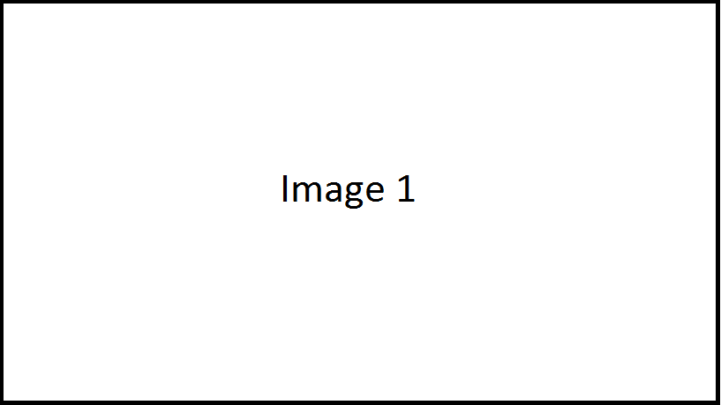

## Figure Figure Title Format

## Config

## Configuration Configuration Title Format

|  |  |  |  |  |  |  |
| --- | --- | --- | --- | --- | --- | --- |
|  |  |  |  |  |  |  |
|  |  |  |  |  |  |  |
|  |  |  |  |  |  |  |

## Table Table Title Format